**VPC TASK – 2:**

**1.Create one VPC, with 1 public subnet and 1 private subnet:**

Create one VPC

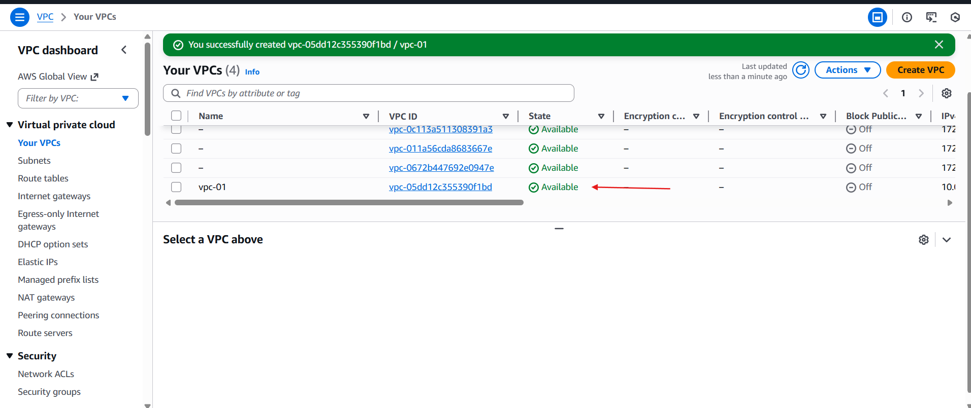

Create 2 subnets one private and one pub

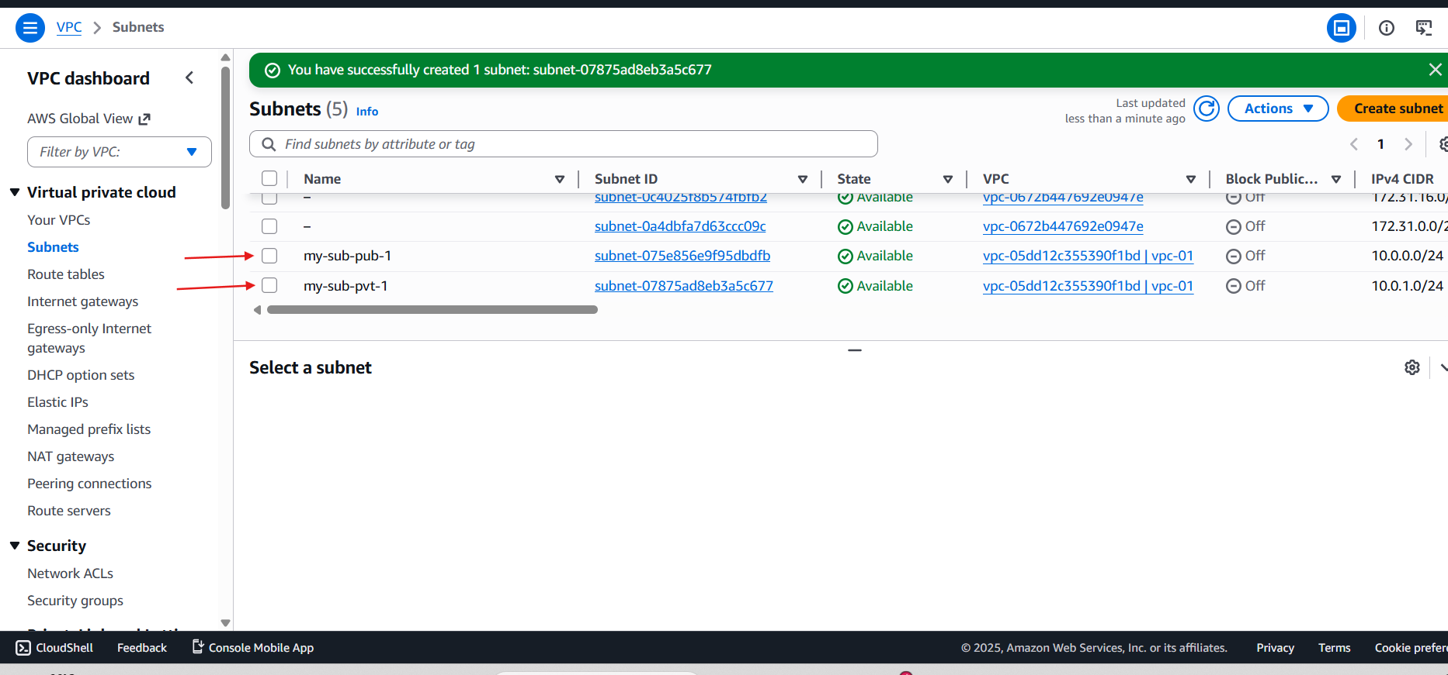

Create internet gate and attached to VPC

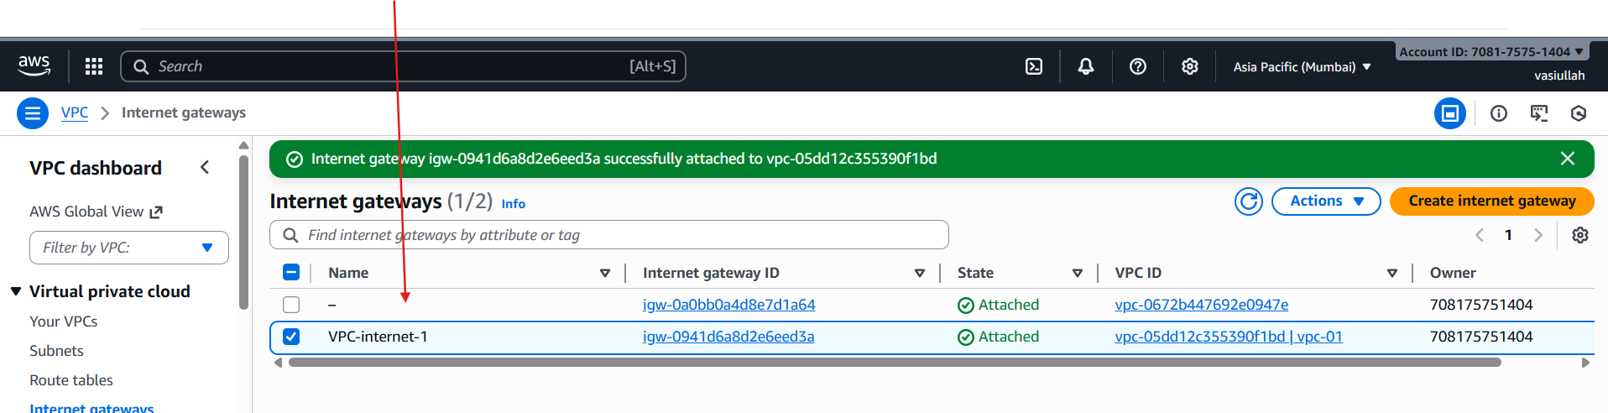

Created the rout table

One pub and one private

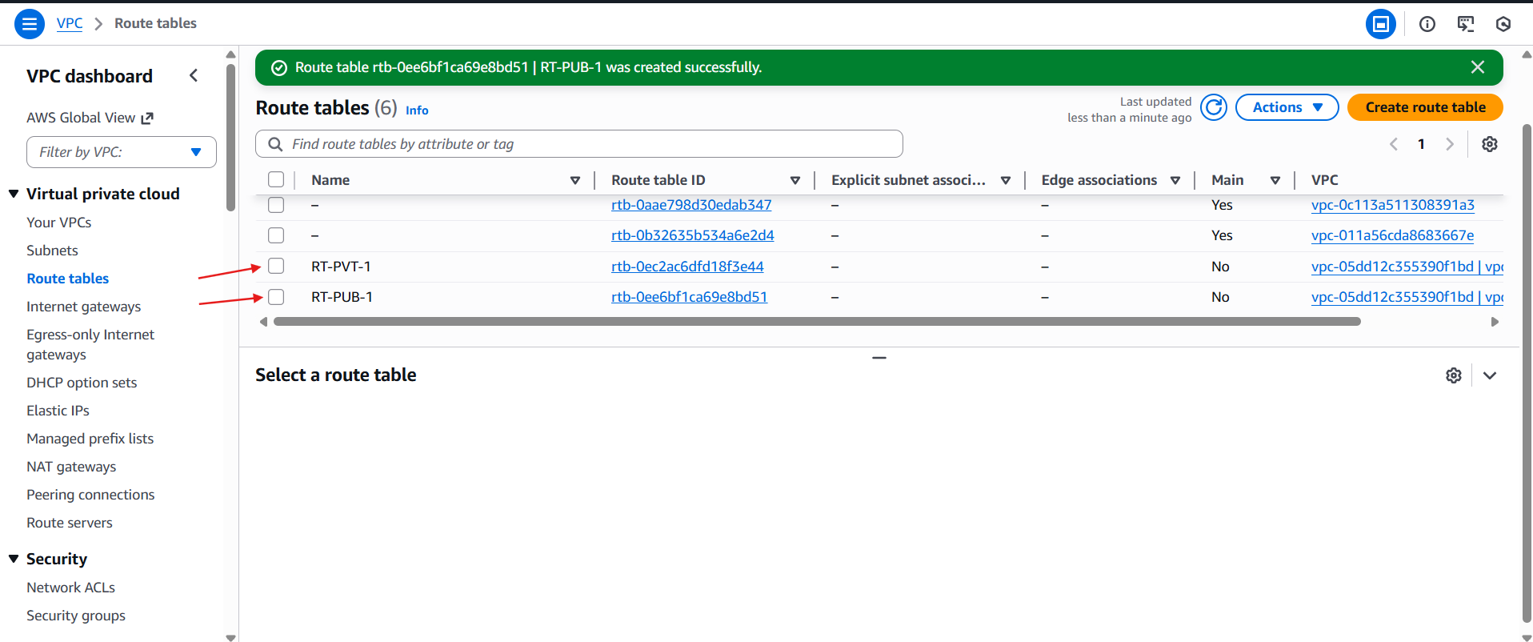

Go to the edit routs

For attach the internet gate way

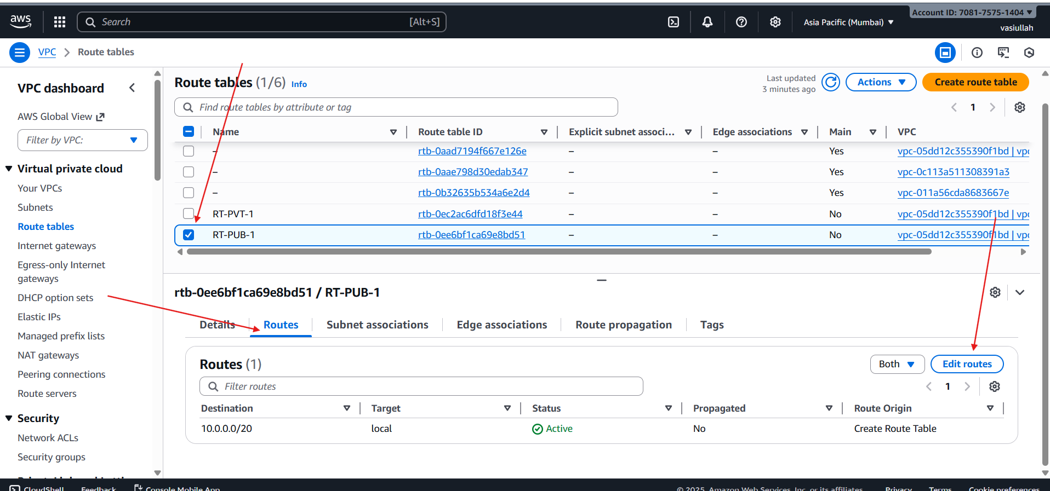

Successfully internet gateway is attached

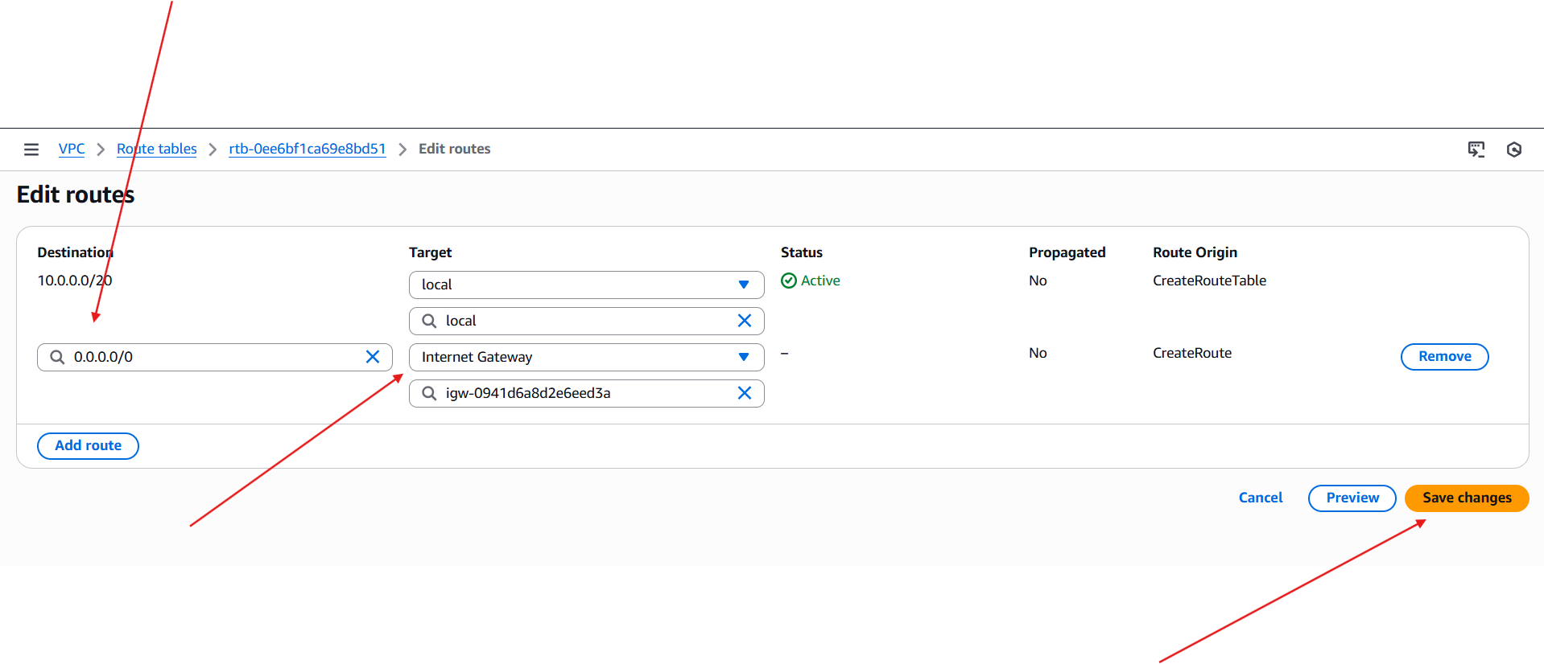

Edited with subnet associate

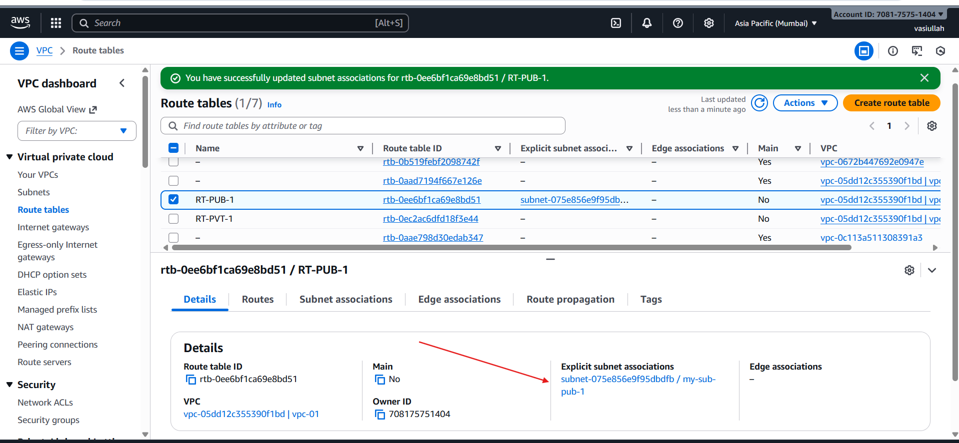

Create one Nat gateway

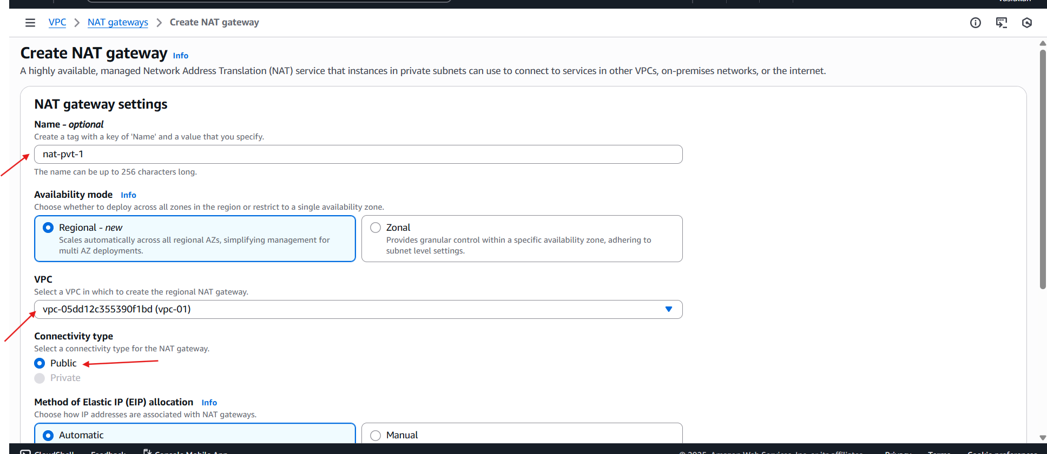

Rout table addached to the inter for public I attachect internet gateway

For private attached NAT gateway

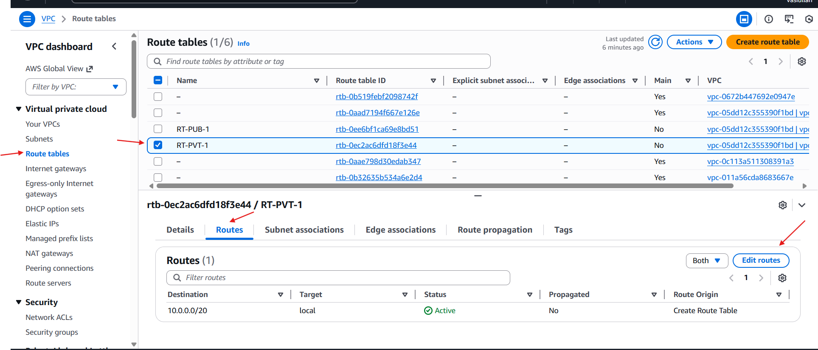

For public I attached nat gate way

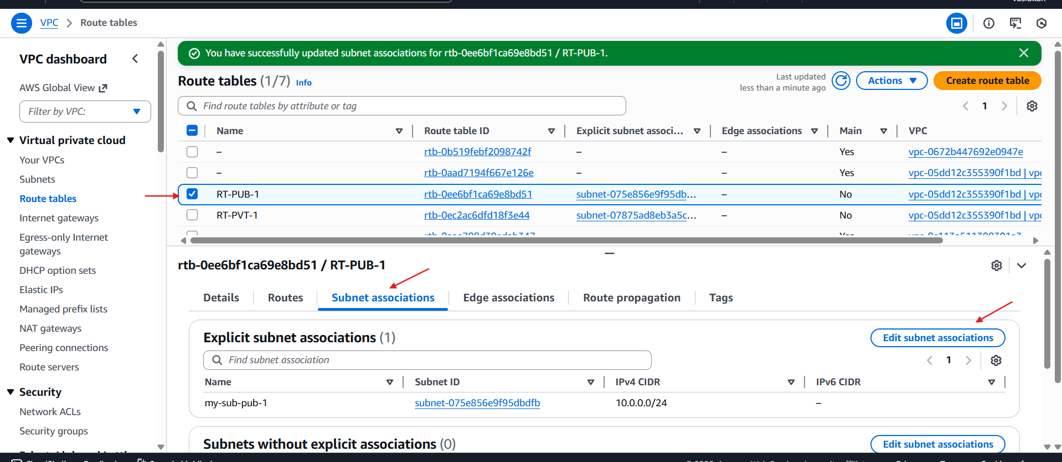

Selected my public subnet and attached to Rout Table public

For private I attached private rout

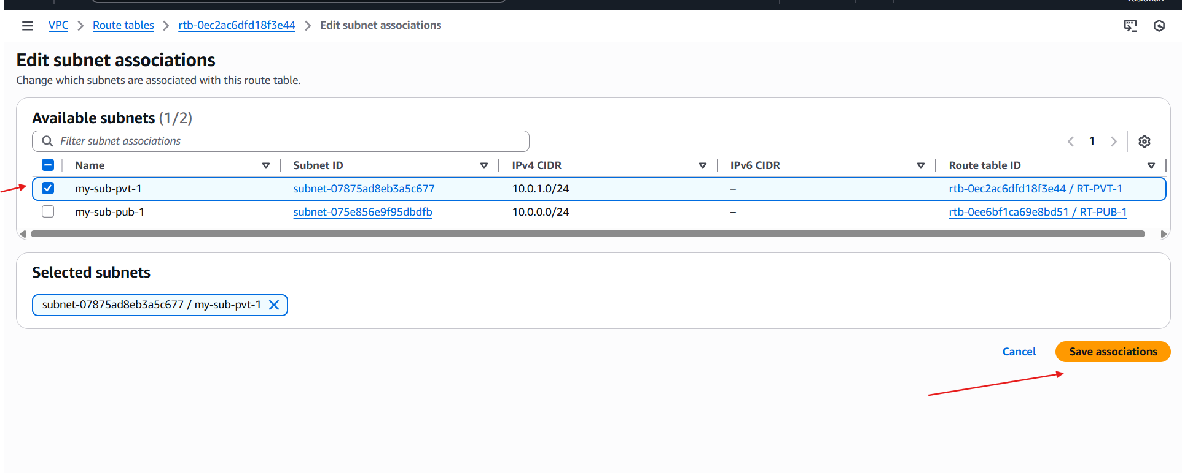vpc resource Map

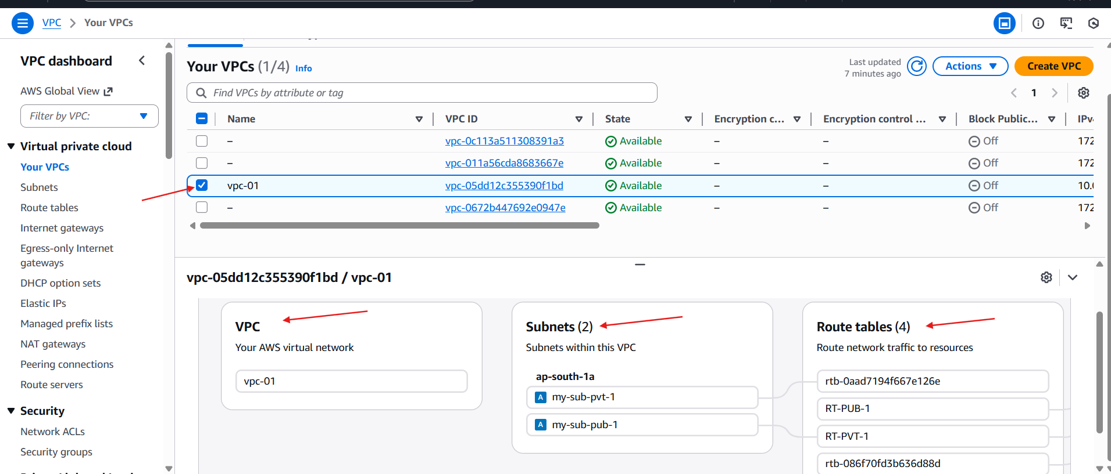

**2. Enable VPC peering for cross-region:**

Region is set for 🡪Europe(lreland)

Launch one ec2

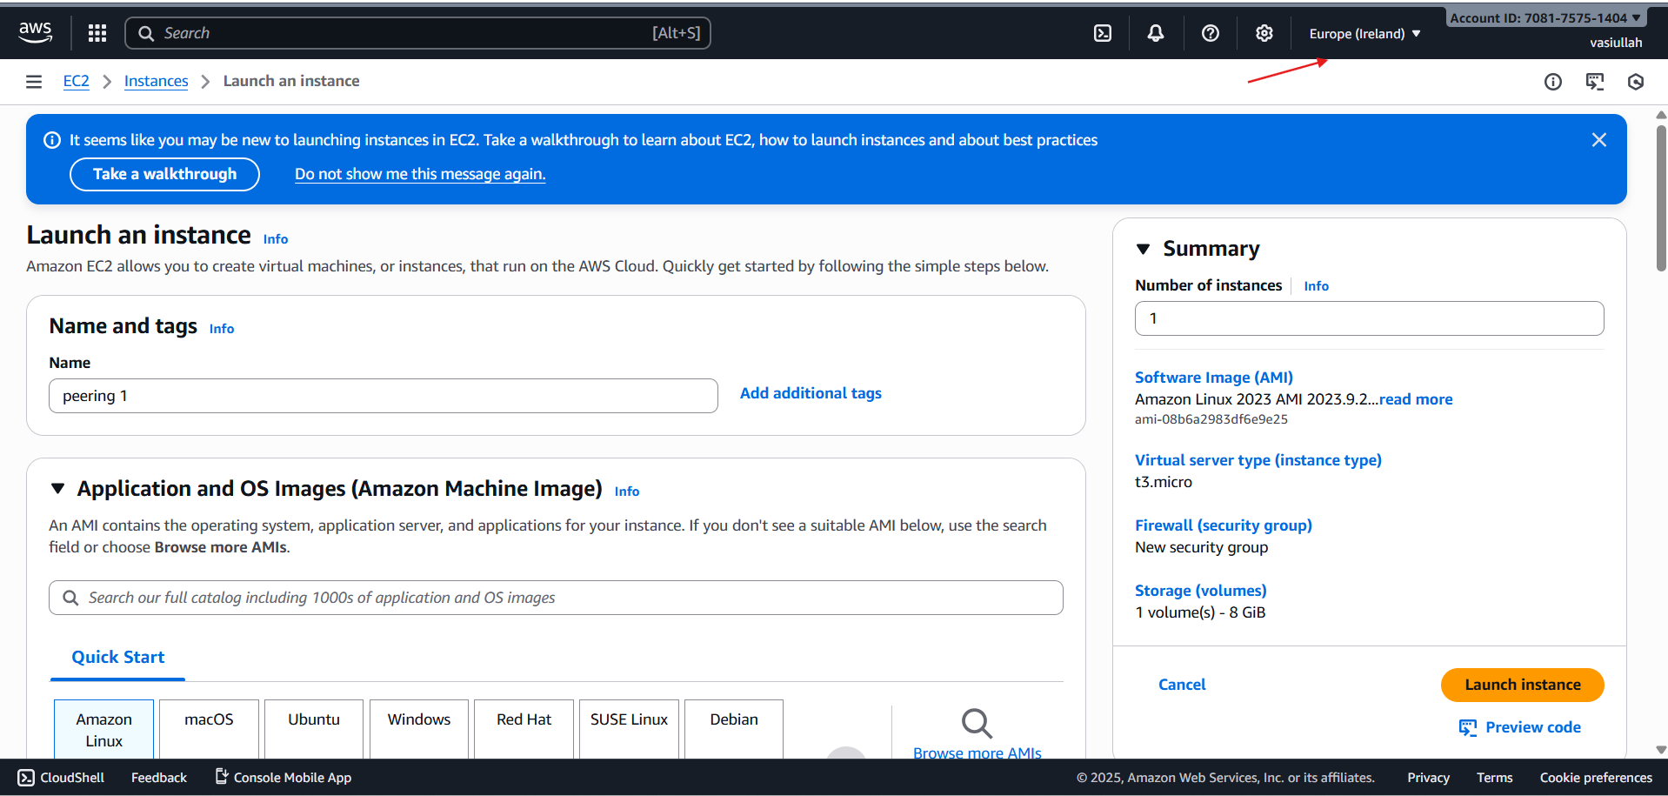

Give required networks and security

And launch the instance

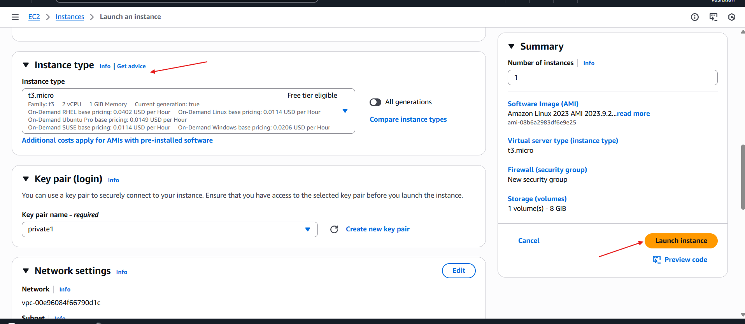

**Change the region**

**Ohio region**

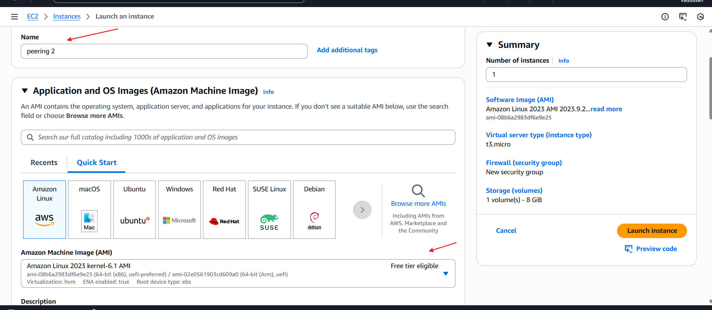

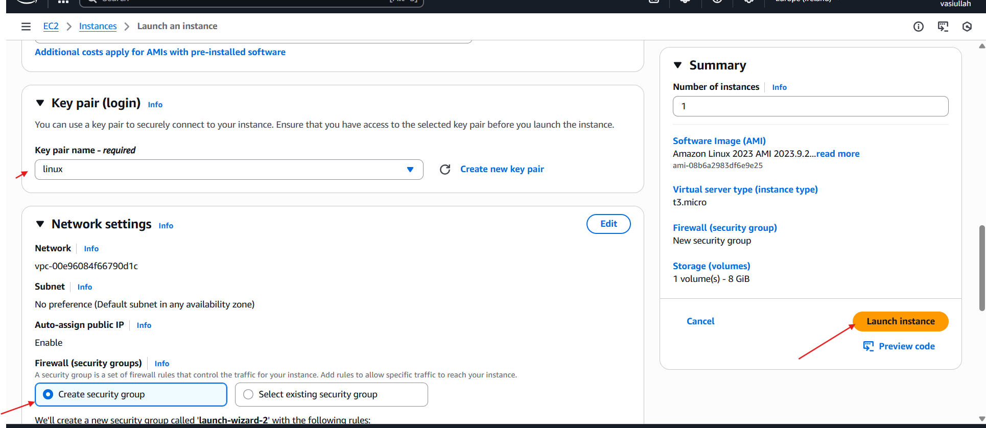

**Ec2 is successfully launched**

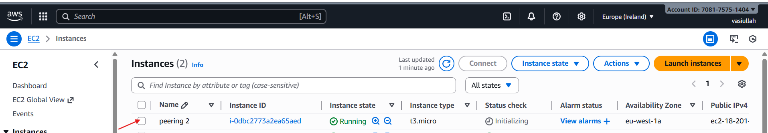

**Create one VPC**

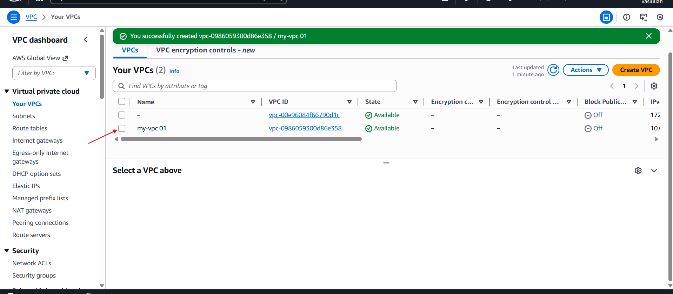

**Go to the peering connection**

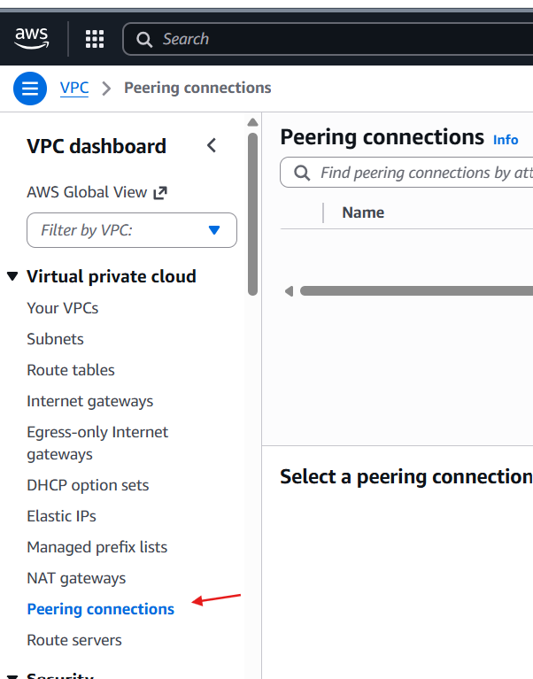

**Create the peering connection**

**Create peering connection** 🡪**select local VPC peering** 🡪**vpc id : kept default**

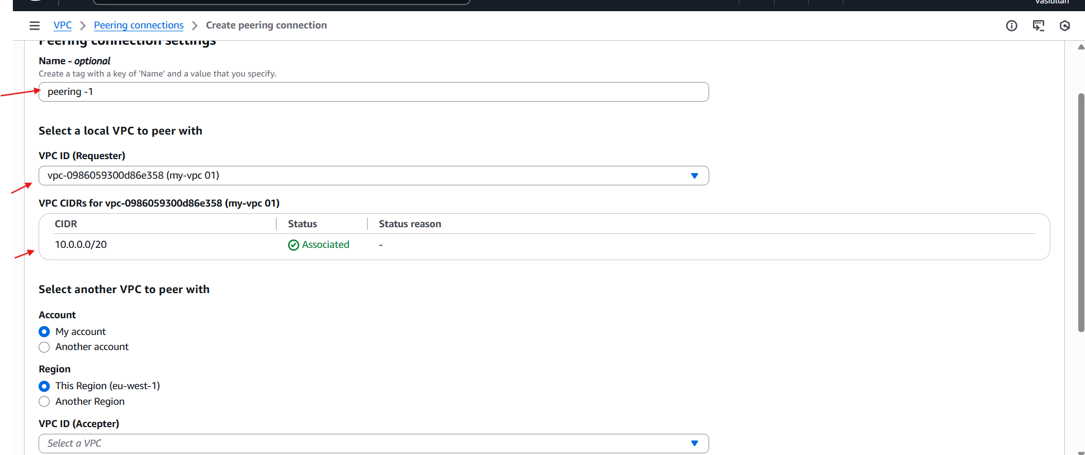

**Go to the another region** 🡪 **VPC**🡪**Your vpc**🡪**already default VPC**

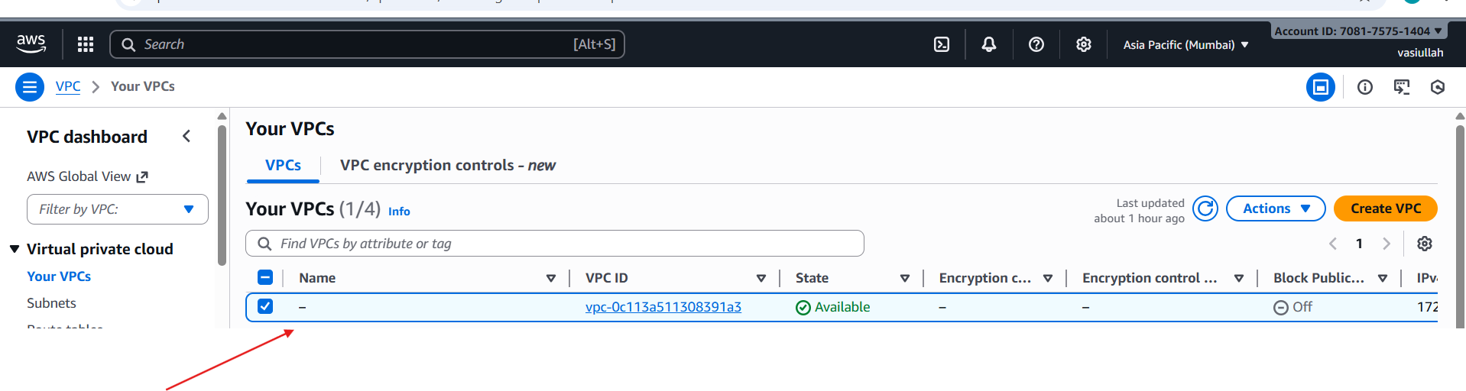

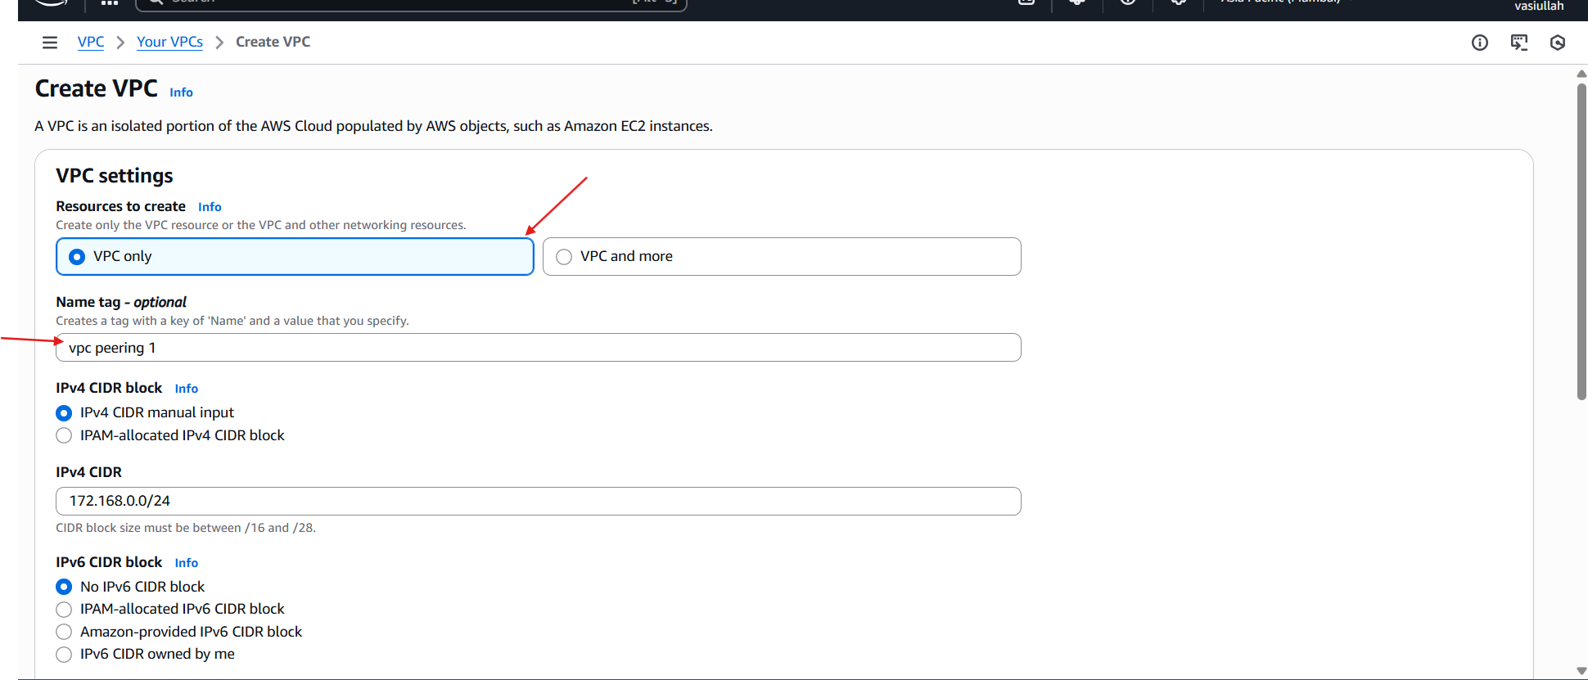

**Go to the Ireland region**

**Select vpc peering**🡪**select your**🡪 **peering connection**🡪**actions**🡪**accept request**

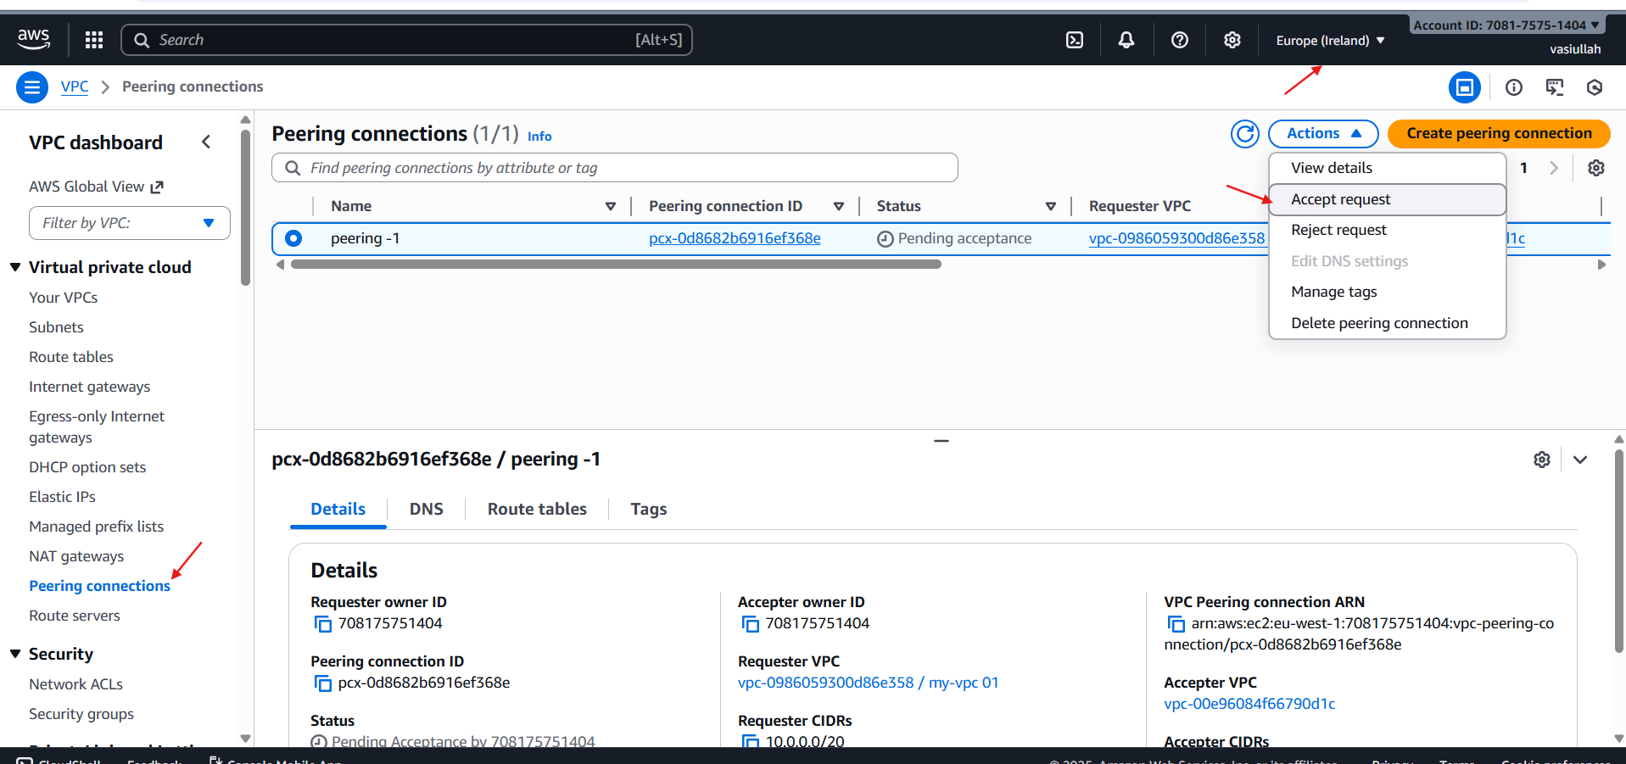

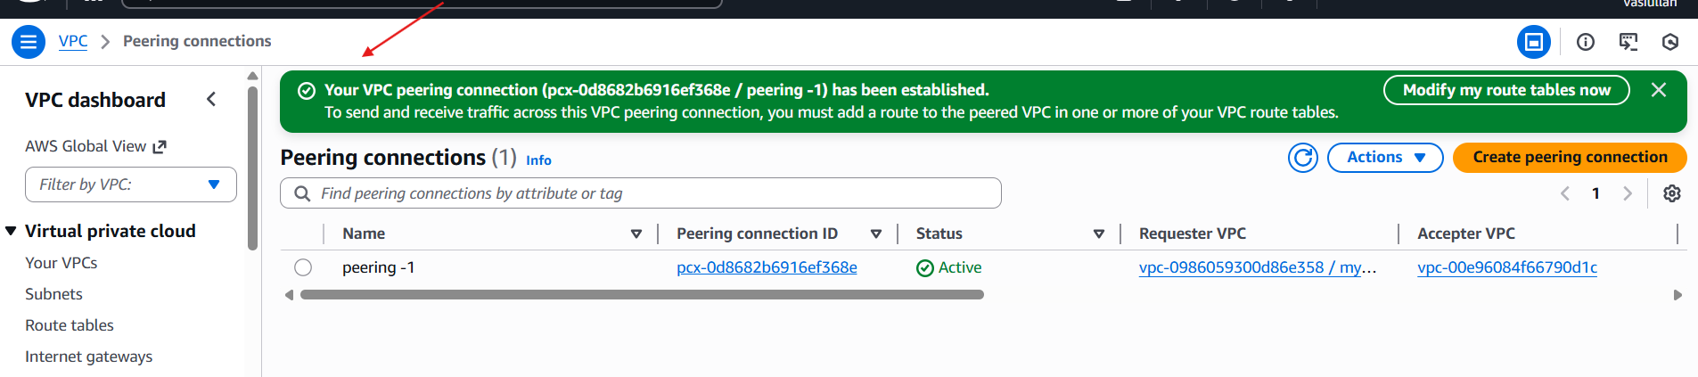

**Go to the ohio region**

**Select RT**🡪**Create RT**🡪**give the name**🡪**select vpc**🡪**and create RT**

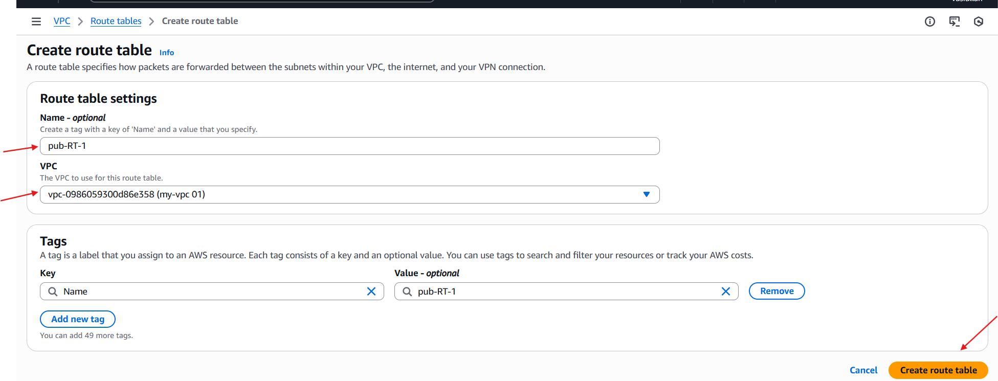

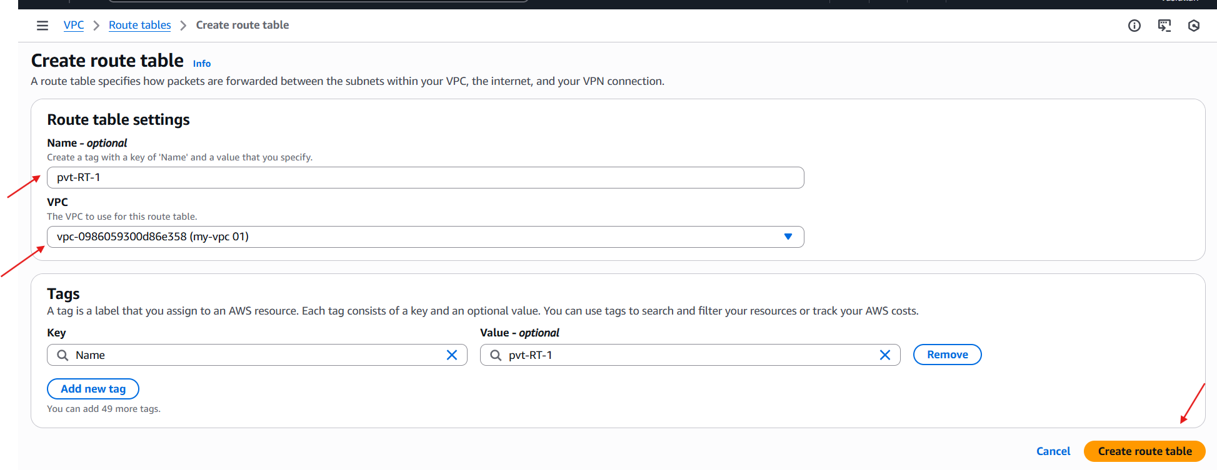

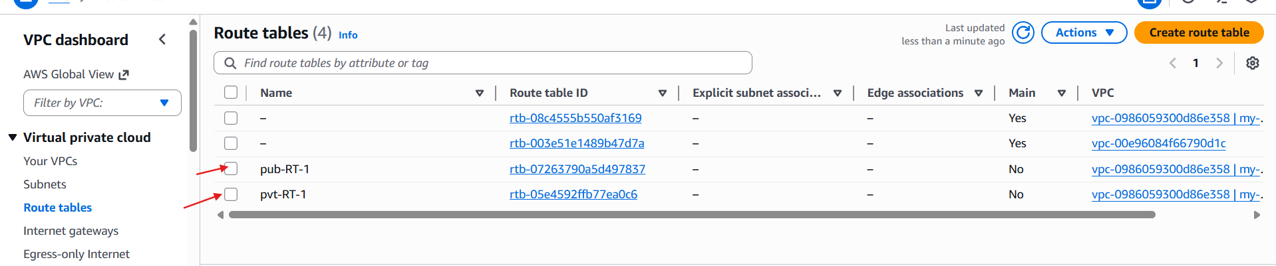

**Create internet gateway and attach to the vpc**

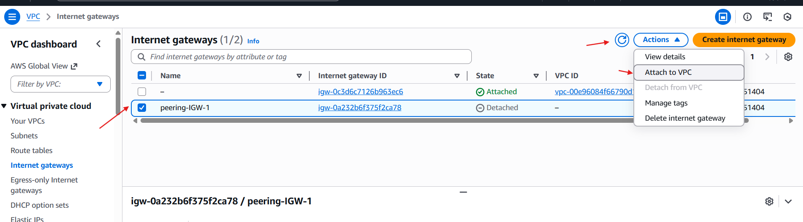

**Go to the rout table and attach to the internet gate way**

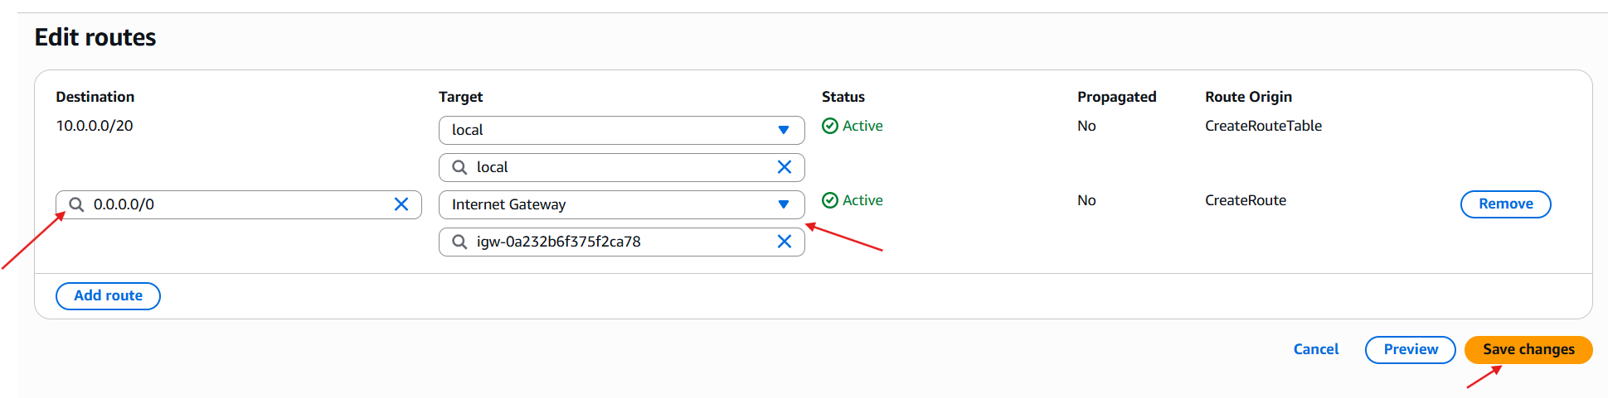

**Internet gate way is attached**

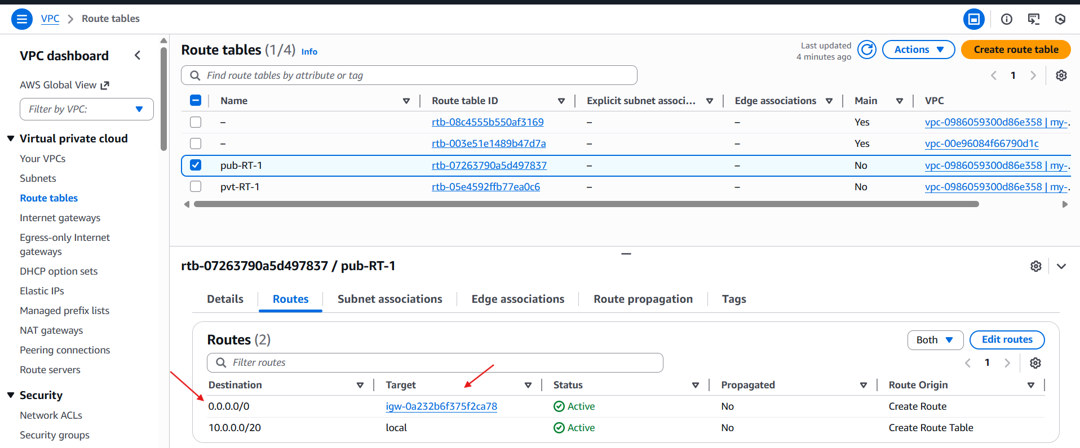

**Change your region to Ireland**

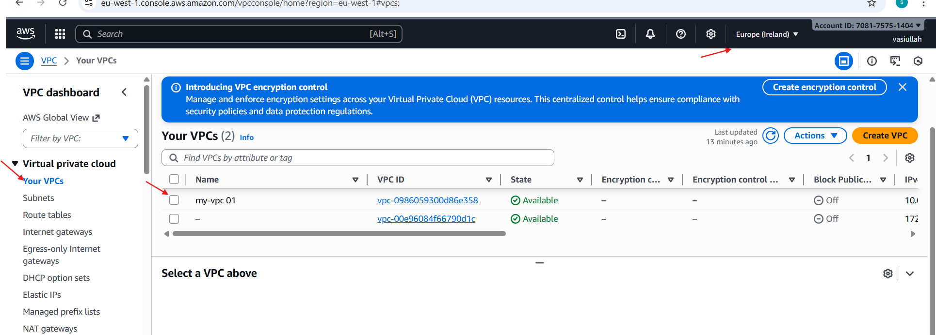

**Go to the ohio region**🡪**RT**🡪

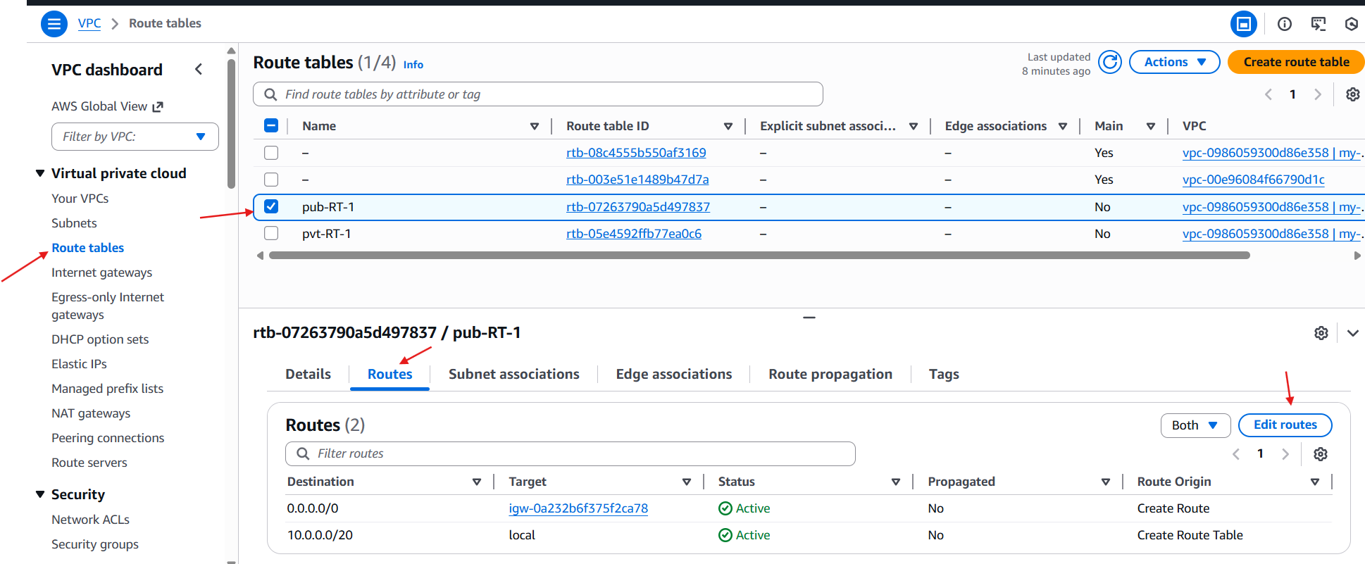

**Go to the destination**🡪**select ip**🡪**select target**🡪**peering connection**

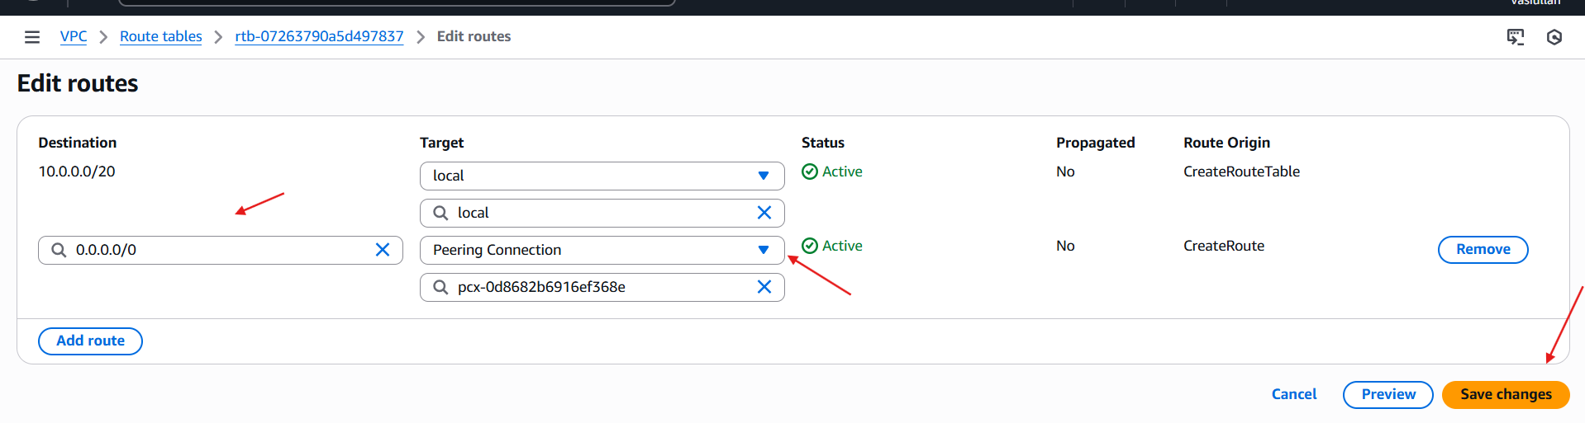

**Successfully connected**

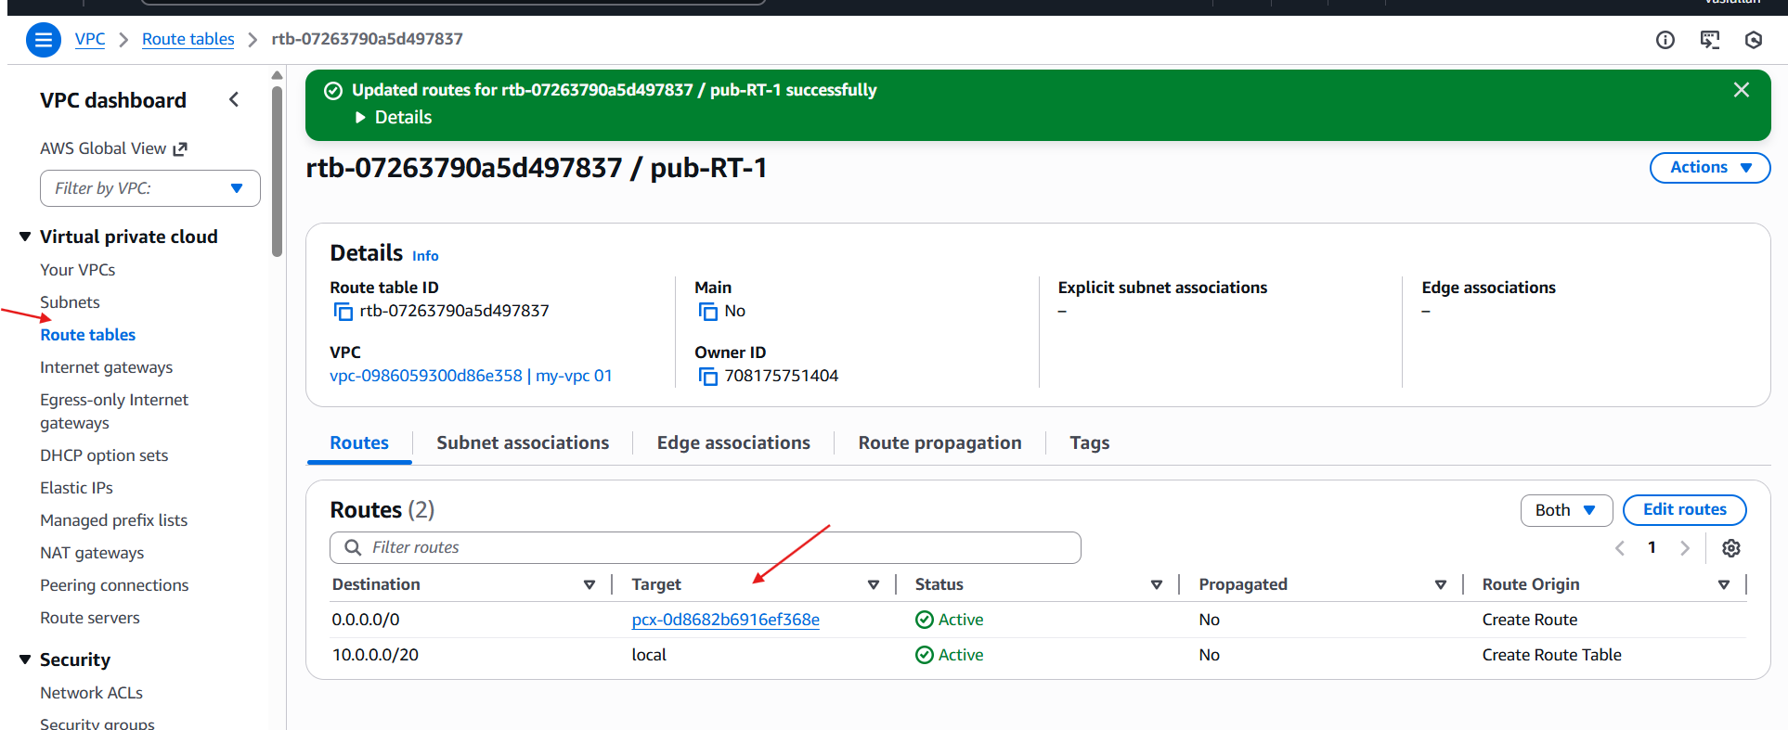

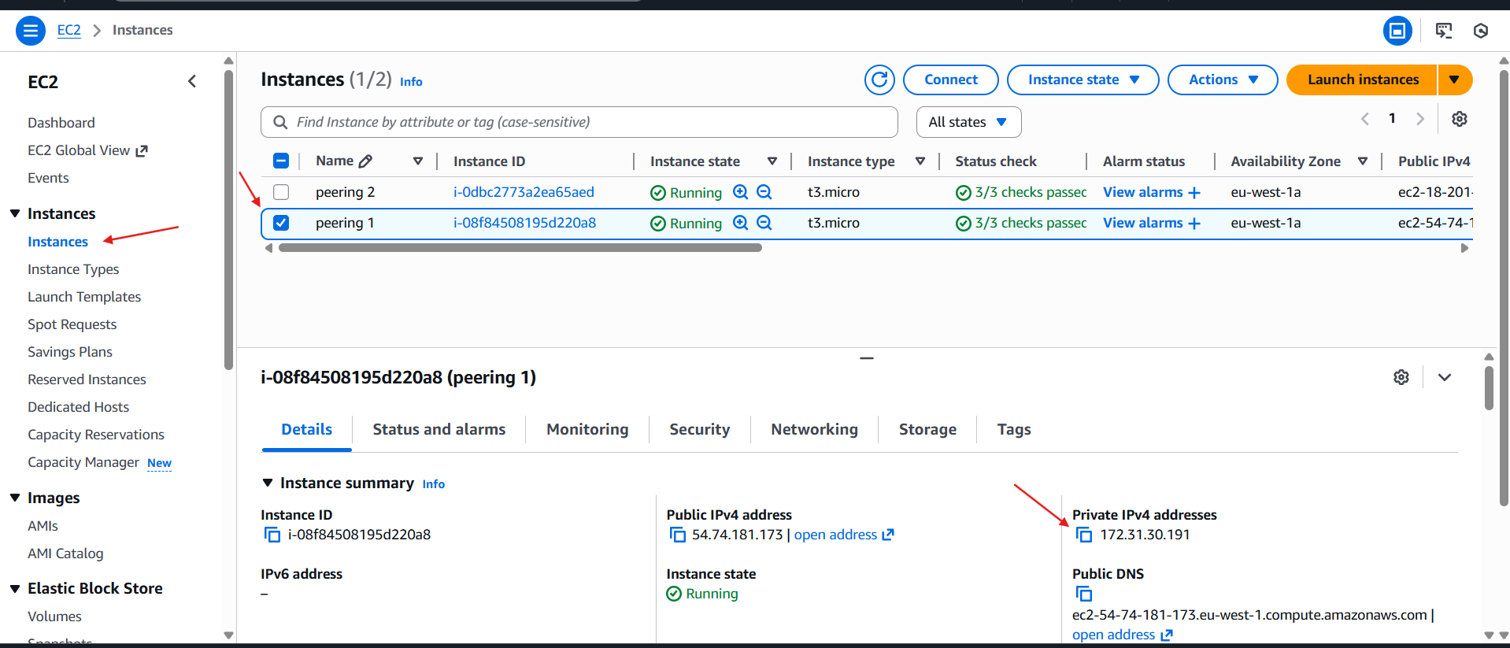

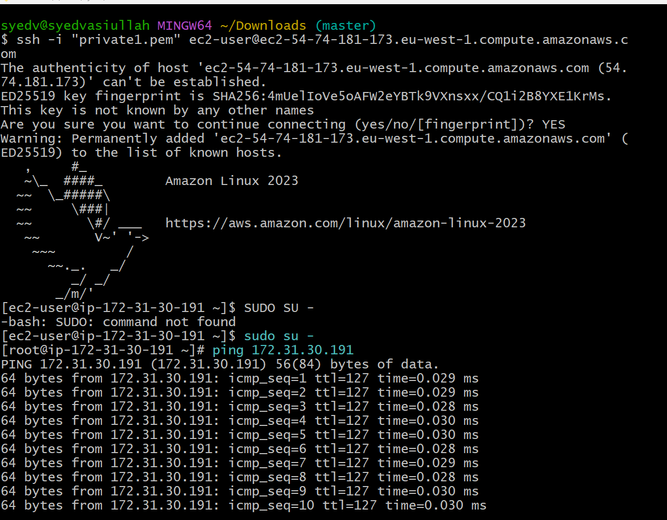

**3. Enable VPC peering for cross-account (you can collaborate with your friend to do this task):**

Created one VPC

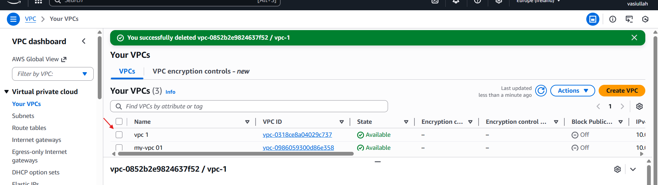

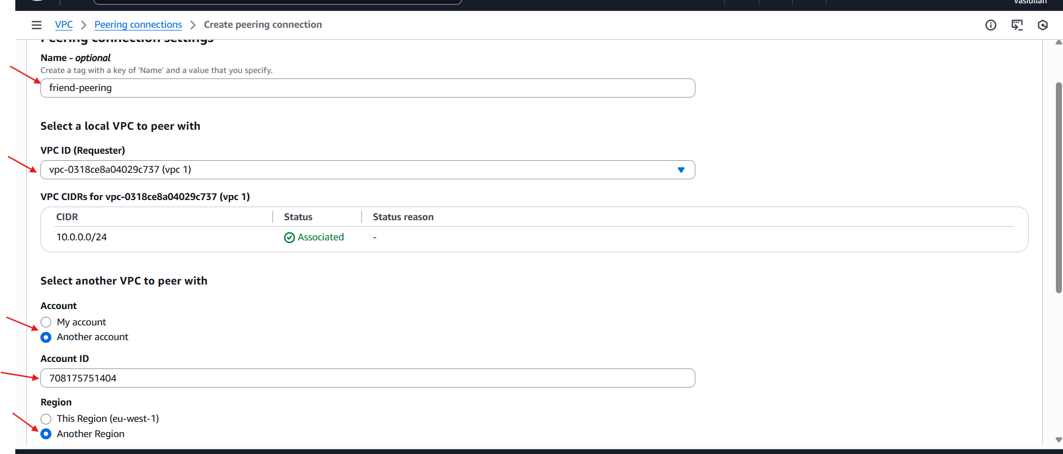

Total details of peering with another account

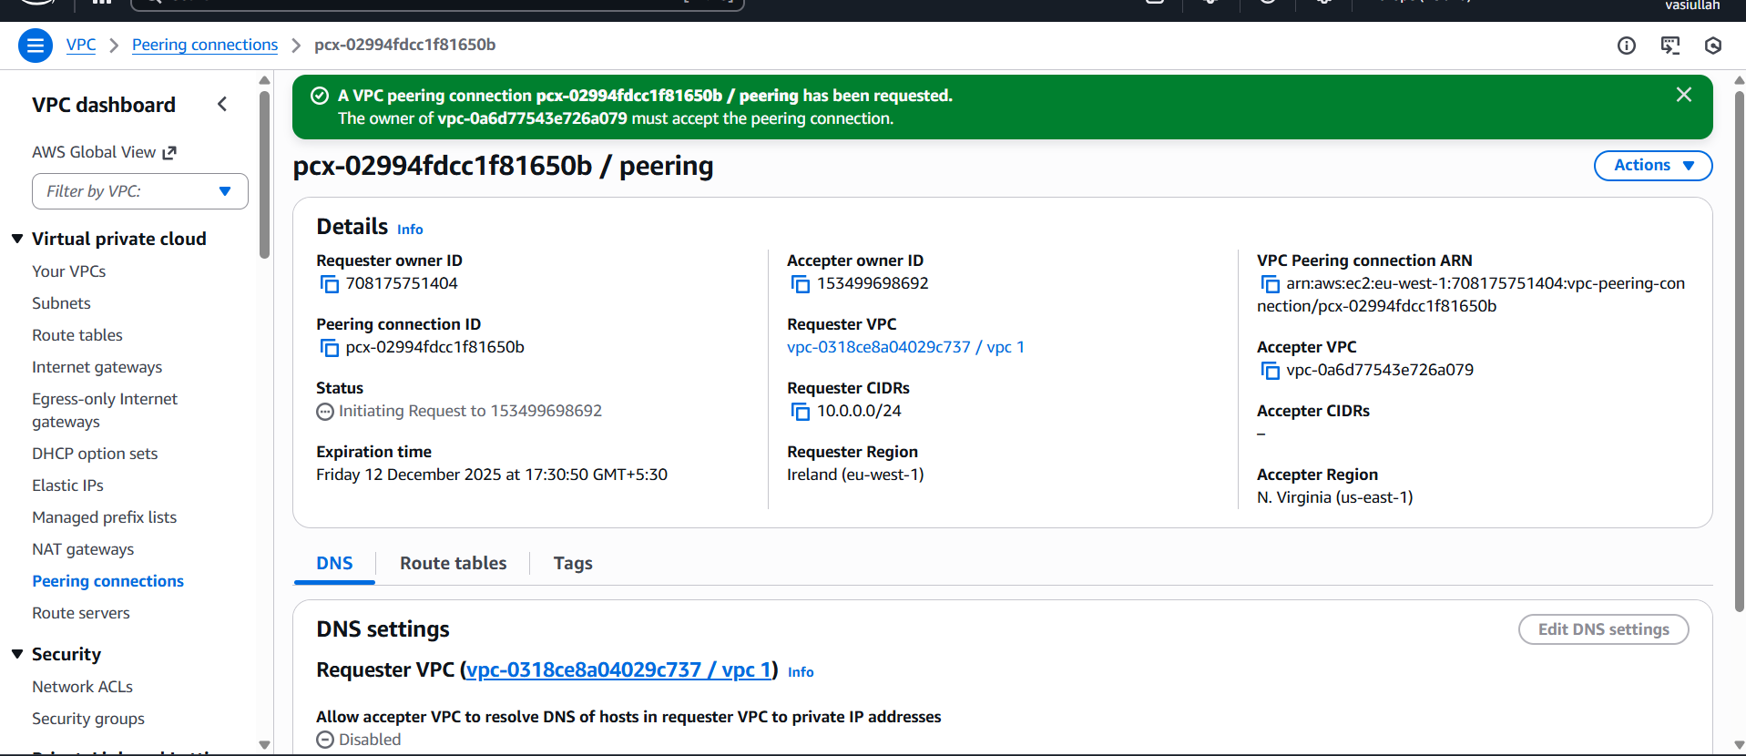

**4. Set up a VPC Transit Gateway:**

**Create 2 VPC**

**VPC-1**

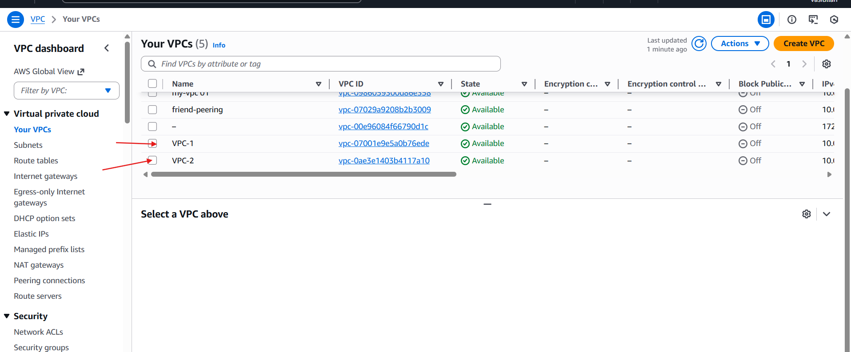

VPC-2

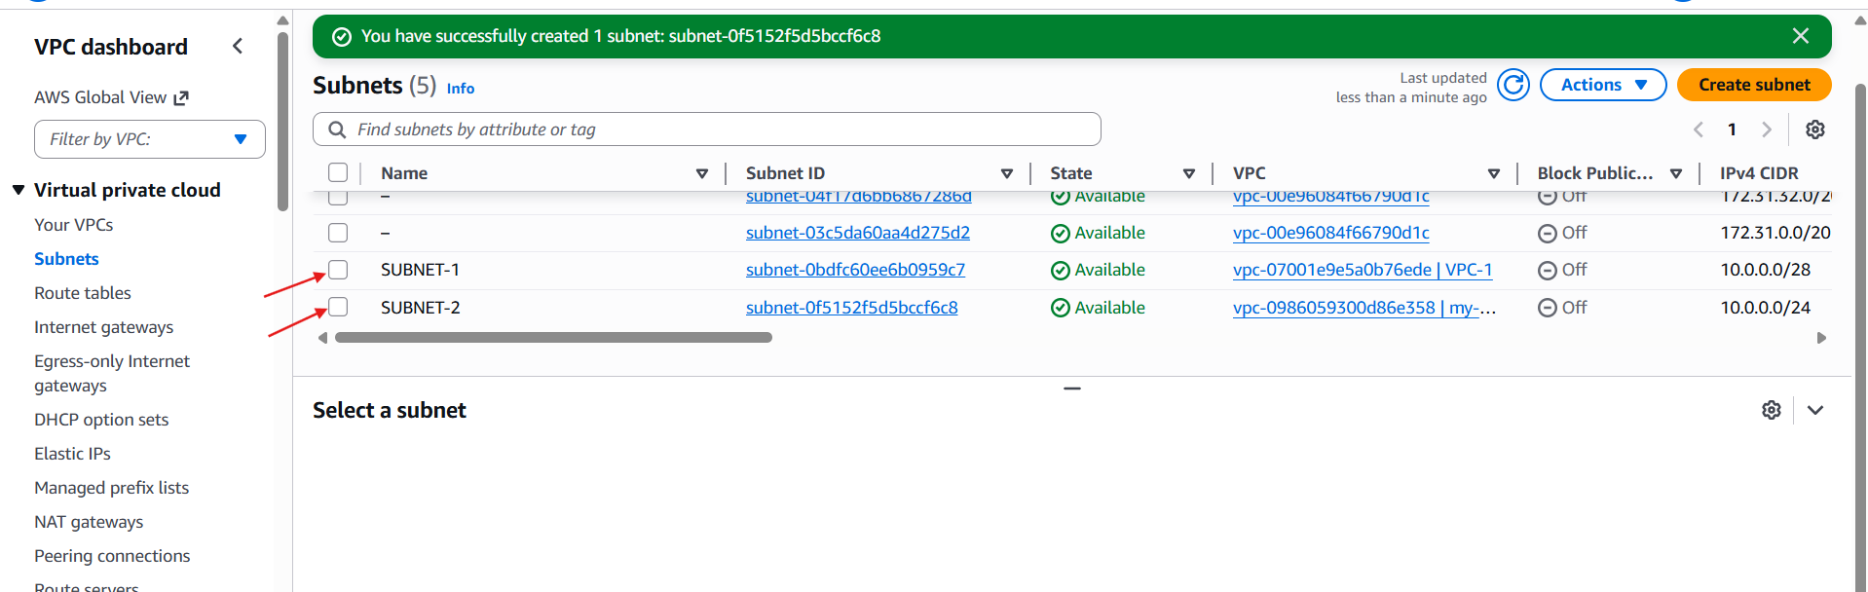

Launch 3 ec2 instances🡪attach vpc

For each instance attach he one on one vpc including with subnets

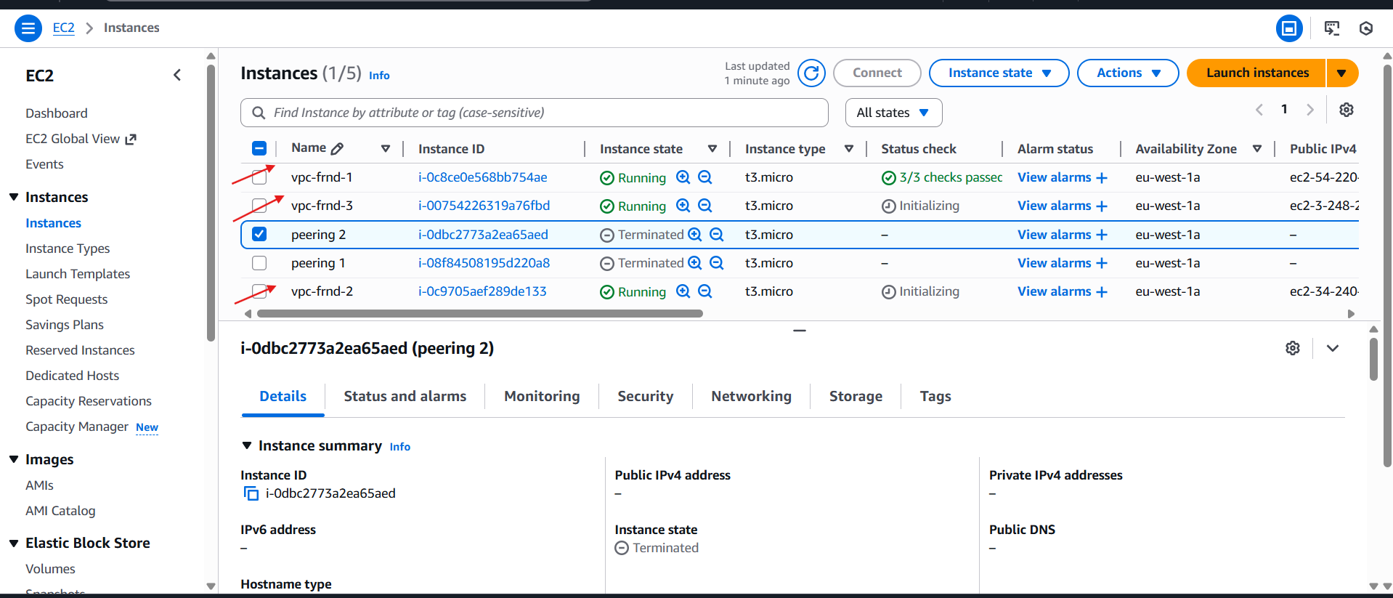

Add in bound rules

Ssh 🡪22

All traffics 🡪 all

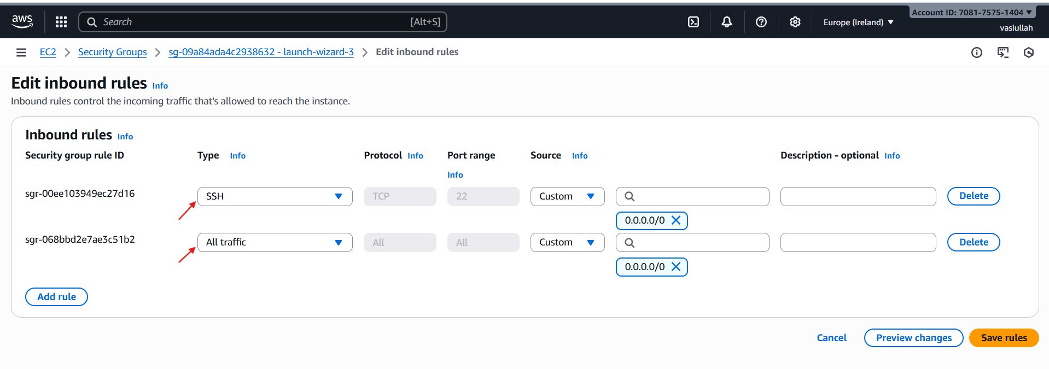

Create transit gateway attachment and attach vpc’s

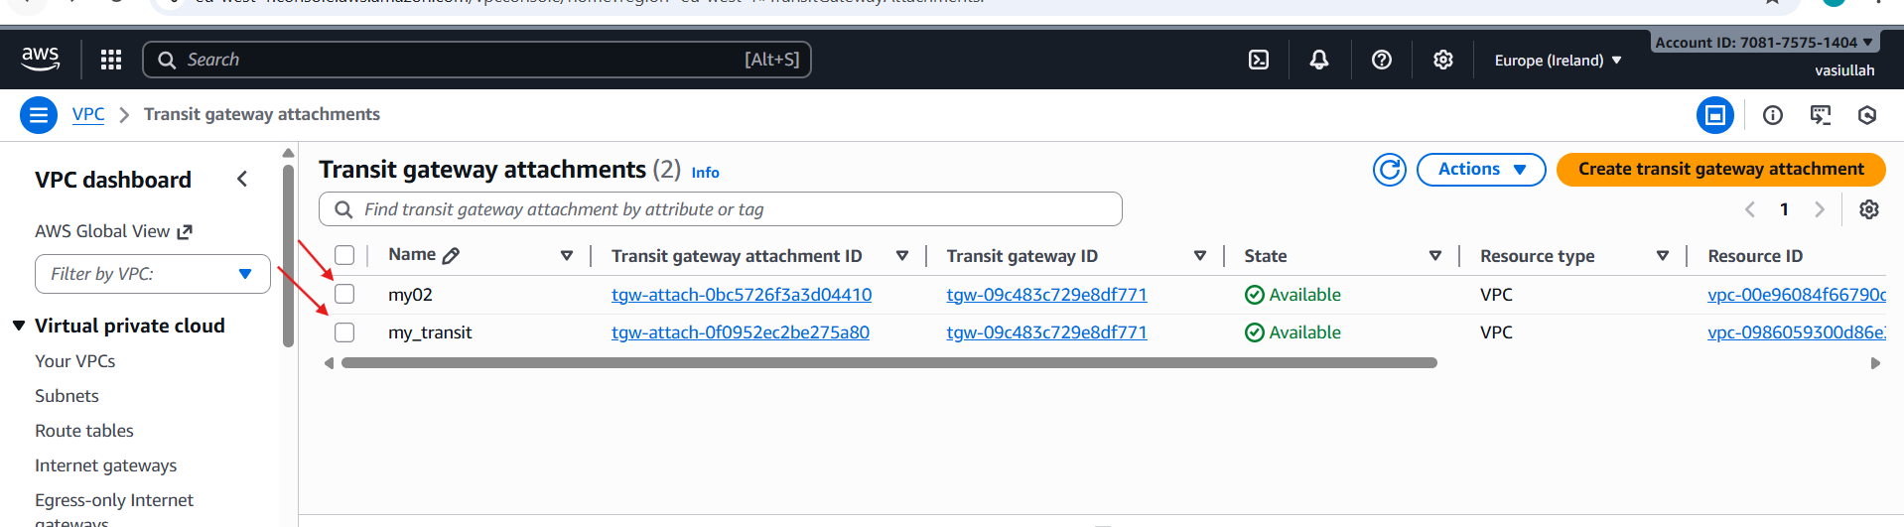

Create 1 rout

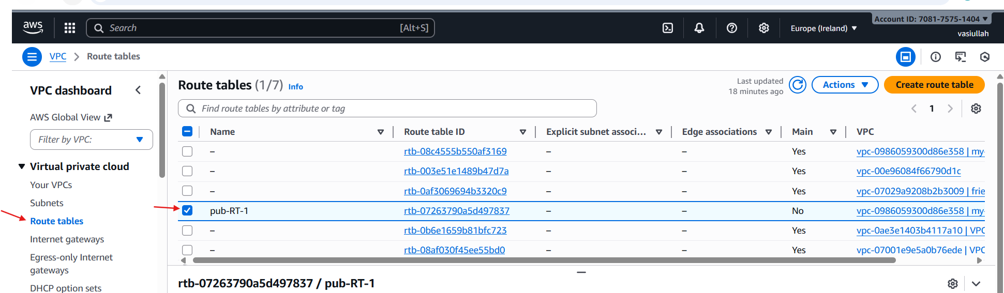

Select RT 🡪 routs 🡪 edit rt

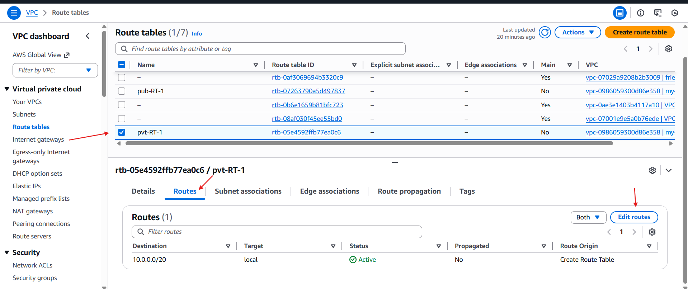

One instance is connected

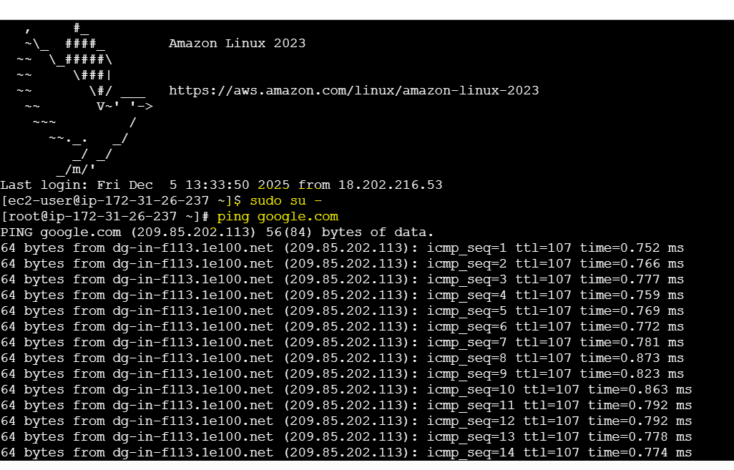

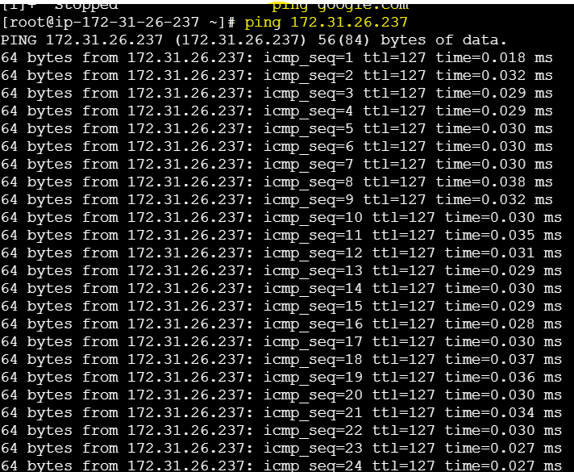

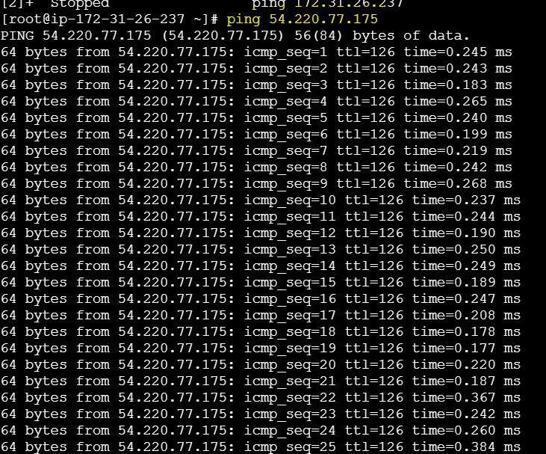

**5. Set up a VPC Endpoint:**

Go to vpc-->create VPC

create internet gateway-->attach to  created VPC

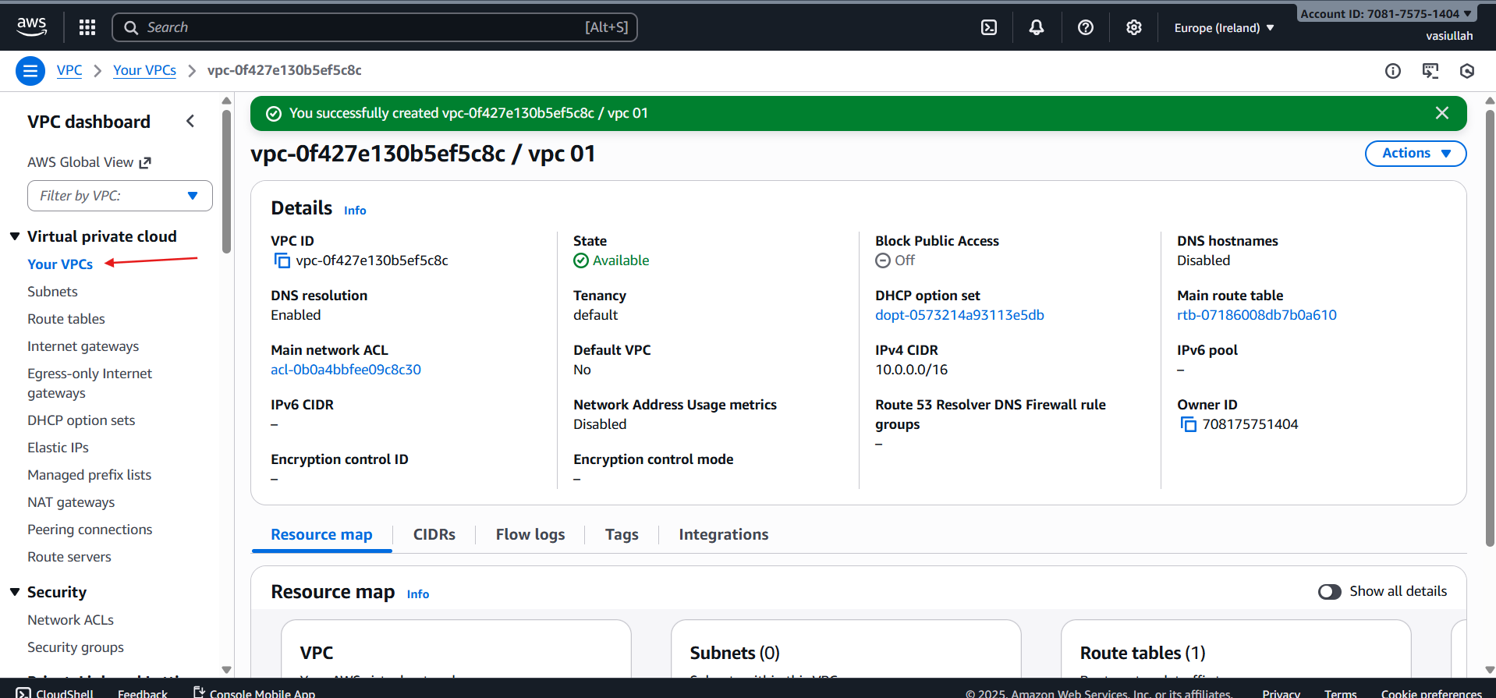

create internet gateway-->attach to  created VPC

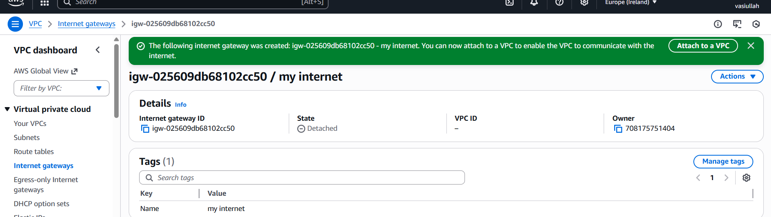

create route tables public and private

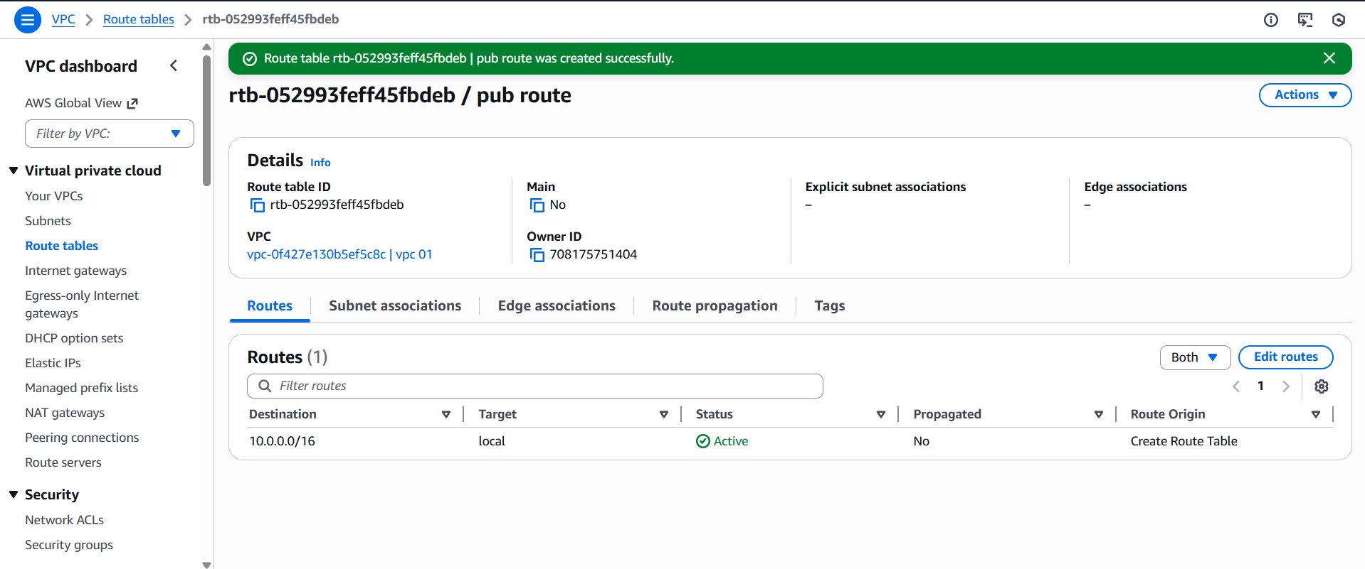

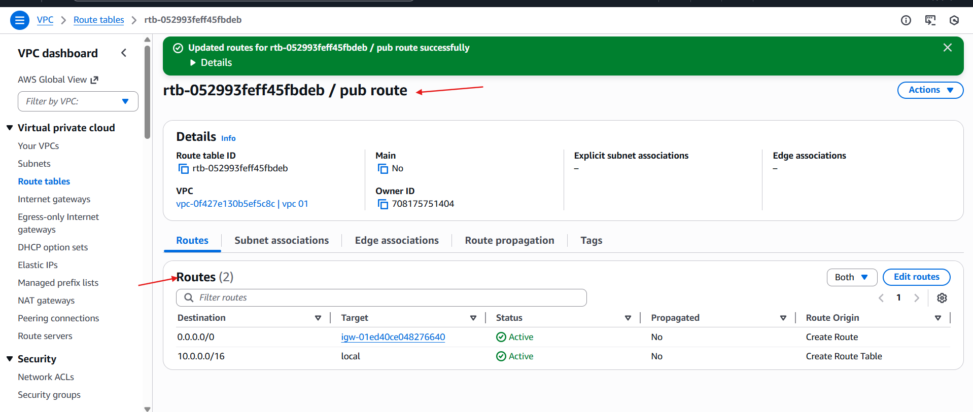

**Create endpoint**

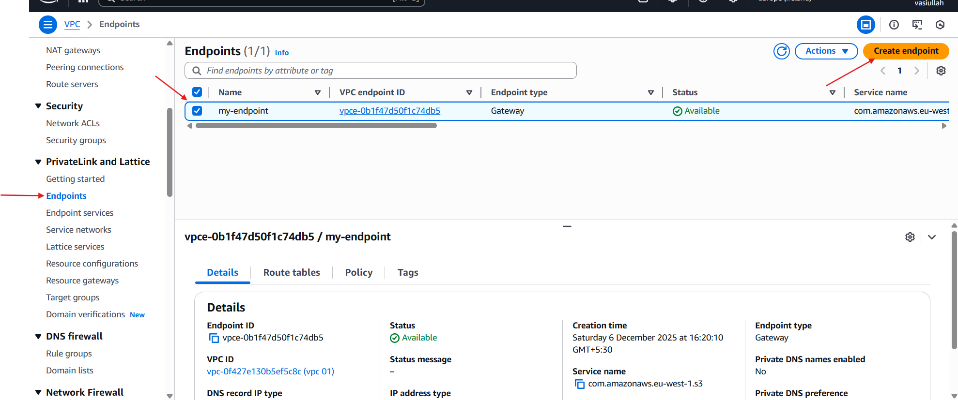

Click **Create bucket**

